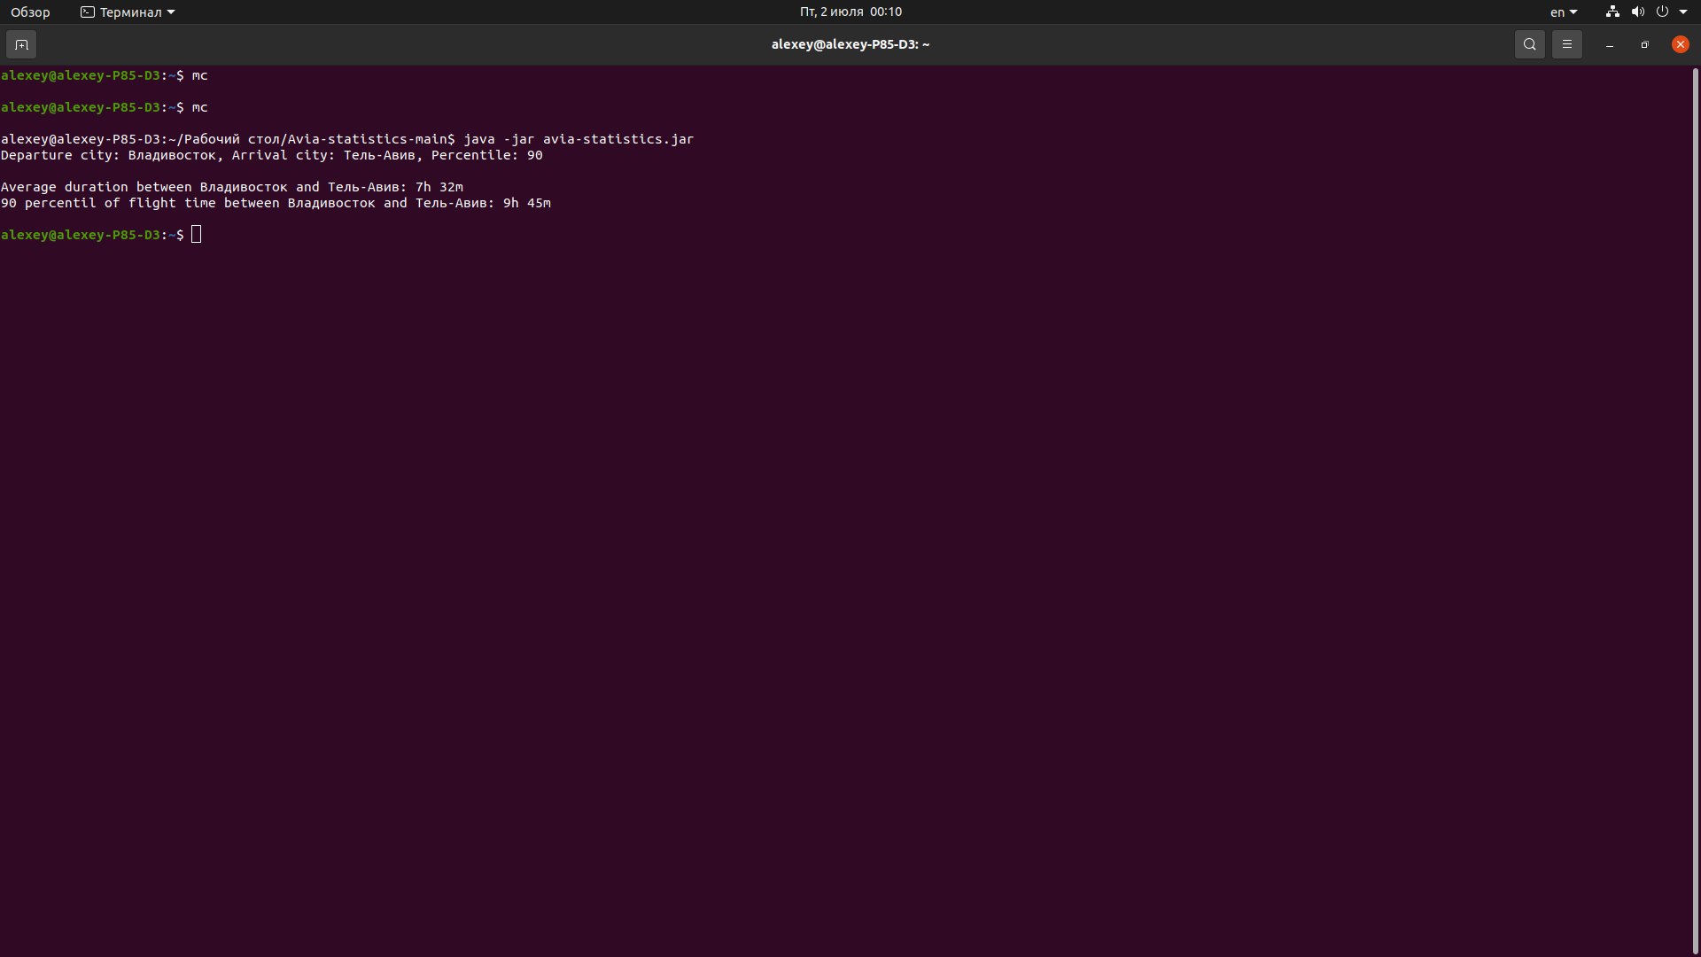
https://github.com/HowToSoloWin/Avia-statistics

alexey@alexey-P85-D3:~/Рабочий стол/Avia-statistics-main$ java -jar avia-statistics.jar
Departure city: Владивосток, Arrival city: Тель-Авив, Percentile: 90

Average duration between Владивосток and Тель-Авив: 7h 32m
90 percentil of flight time between Владивосток and Тель-Авив: 9h 45m

